**Batch: A-3 Roll No.: 16010122104**

**Experiment / assignment / tutorial No. 9**

**Grade: AA / AB / BB / BC / CC / CD /DD**

**Signature of the Staff In-charge with date**

|  |
| --- |
| Title: Create a RESTful API server in Express and Node.js. Implementation + Testing application using postman/Thurderclient |

**AIM:** Create a RESTful API server in Express and Node.js. Implementation + Testing application using postman/Thurderclient

**Problem Definition:**

**Resources used:**

**_____________________________________________________________________**

**Expected OUTCOME of Experiment:**

**CO 3:** **Test the concepts and components of various front-end, back-end web app development technologies & frameworks using web development tools.**

**___________________________________________________________________**

**Books/ Journals/ Websites referred:**

1. Shelly Powers Learning Node O’ Reilly 2 nd Edition, 2016.

**Pre Lab/ Prior Concepts:**

**Methodology:**

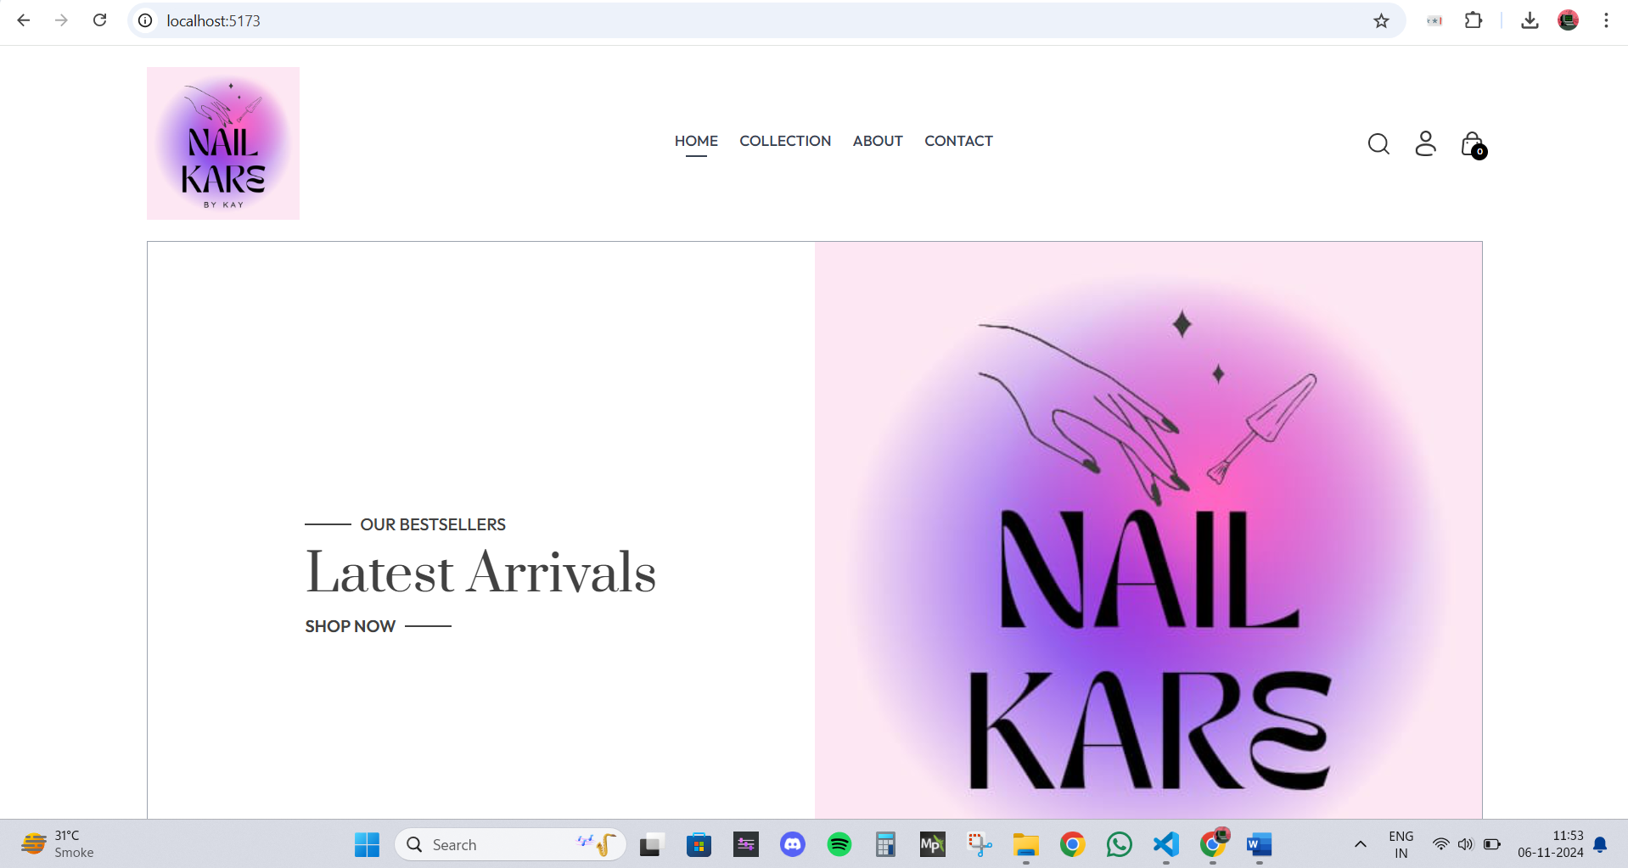

**Implementation Details:**

**Steps for execution:**

**Conclusion:**